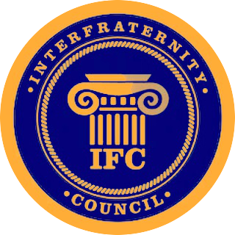
Boise State IFC Delegate Meeting
4/13/17 – 6:00 pm - Cataldo

Call to Order Time:
- Attendance
  - Chapter Delegates:
Chapter Name: | Representative Name, N/A if absent:
Alpha Kappa Lambda
Delta Sigma Phi
Delta Upsilon
Kappa Sigma
Phi Gamma Delta
Pi Kappa Phi
Sigma Chi
Tau Kappa Epsilon
  - Visitor Attendance & Announcements:
    - Alpha Tau Omega visiting us today

- Minutes and Agenda Items:
  - Amendments to the agenda?
    - Any amendments?:

    - (Optional) Approval of the minutes?

- Officer Reports
  - President
    - Working with Panhellenic President on executing Greek Awards
    - Authored constitutional amendments
  - Vice President of External Affairs
    - Meeting with Amy, Jacob, Jenna and Christine to consolidate finances for Greek Week
    - Created Report for future ideas
  - Vice President of Internal Affairs
    - Met with Amy, Austin, Jenna, and Christine to consolidate finances for Greek Week
    - Dues will be collected today
  - Vice President of Recruitment
    - Created report consolidating recruitment dates, times, locations and ideas
    - 2 recruitment events
    - Working on Summer Recruitment processes
  - Vice President of Fraternal Affairs
    - ?

- Unfinished Business
  - Beta Psi Chapter of the Phi Gamma Delta Fraternity was initiated and chartered, Congratulations!
  - Summary of last meetings crucial amendment 002 Unanimous Consent Clause
  - Collecting Dues:
  - Greek Week Financial Distribution:
    - DU Won First Place
      - Estimated $2,500 going to their philanthropy
      - Will be in contact with chapter leadership on how it is distributed to you

- New Business:
  - Greek Awards, Sunday April 30th at 10:30 am, Brunch. Business/casual/formal attire
    - Award Nominations Due Tomorrow, Friday 4/14 by 5:00 pm to Brian McDermott
    - Superlative awards coming out week of:
      - Suggestions?:
    - Explanation:
  - Amendment 003: Executive Appointment Authority
    - Distribute Job descriptions
    - If passes let them know the applications will open Friday and close next Friday then interviews will be the week following.
  - Amendment 004: Repeal of the GPA Stipulation Clause
  - Amendment 005: Repeal of the Financial Rollback Clause

- Announcements
  - Fraternity Chapter Announcements:
    - Sigma Chi: Derby Days Final Event, Field Day is Friday from 2pm – 6pm IM Field

- Adjournment: Adjourn at time:

