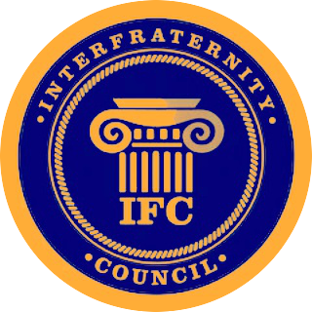
IFC Agenda for 3-9-17
6:00 pm in Student Diversity Center

- Call to Order @6:08
  - Role call
    - Alpha Kappa Lambda - Present
    - Delta Sigma Phi - Present
    - Delta Upsilon - Present
    - Kappa Sigma - Present
    - Phi Gamma Delta - Present
    - Pi Kappa Phi - Present
    - Sigma Chi - Absent
    - Tau Kappa Epsilon - Present

  - Visitor Announcements:
i. Jenna Adkins & Lindsey Raaker speaking about their campaign for
President & Vice-President of ASBSU

- Approval of Minutes
  - Minutes from last meeting
i. Approved

  - Corrections for agenda
i. None

- Officer Reports
  - President
    - In discussion with Panhellenic President Kylee Webster and Multicultural Greek Council President on doing Greek Awards

  - Vice President of External Affairs
    - Greek Week update

  - Vice President of Internal Affairs
    - Chapter dues are being pushed back to allow for complaint corrections
  - Vice President of Recruitment
    - Recruitment meeting 3pm Sunday 3/12/17 Chief Joseph Room

  - Vice President of Fraternal Affairs
    - Working on Newsletter with Panhellenic

- Unfinished Business
  - None

- New Business
- None

- Announcements

  - Guest Announcements
    - None

  - Fraternity Announcements

    - Alpha Kappa Lambda- none
    - Delta Sigma Phi- Basketball Tournament Sunday 3/12
    - Delta Upsilon- none
    - Kappa Sigma - Just chartered on March 4th
    - Phi Gamma Delta (FIJI) - Chartering on April 8th
    - Pi Kappa Phi - none
    - Sigma Chi - none
    - Tau Kappa Epsilon - St. Frattys Day Dance

VII. Adjourned @ 6:36 pm

