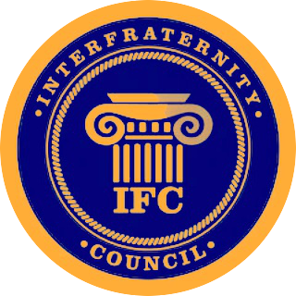
Boise State IFC Delegate Meeting
3/2/17 - Cataldo

- Call to Order
  - Role call
    - Alpha Kappa Lambda
    - Delta Sigma Phi
    - Delta Upsilon
    - Kappa Sigma
    - Phi Gamma Delta (FIJI)
    - Pi Kappa Phi
    - Sigma Chi
    - Tau Kappa Epsilon

  - Visitor Announcements

- Approval of Minutes
  - Minutes from last meeting

  - Corrections for agenda

- Officer Reports
  - President
    - Kylee and I are meeting with Boise State’s Food Sustainability club they’re looking for volunteers they take all the food the vendors on campus don’t use and donate it to homeless shelters, and food pantries/soup kitchens

  - Vice President of External Affairs
i. Greek Week is coming

  - Vice President of Internal Affairs
i. Financial Report

  - Vice President of Recruitment
i.

  - Vice President of Fraternal Affairs
i. First edition of the newsletter to be published by March 12th

- Unfinished Business
- Vote on proposed Constitutional Amendment #1
- Yea:
- Nay:
- Abstain:
- Result:

- New Business
- Jacob Muttart

- Announcements

  - Guest Announcements

  - Fraternity Announcements

    - Alpha Kappa Lambda
    - Delta Sigma Phi
    - Delta Upsilon
    - Kappa Sigma
    - Phi Gamma Delta (FIJI)
    - Pi Kappa Phi
    - Sigma Chi
    - Tau Kappa Epsilon

- Adjournment

